**NYC Citi Bike Analysis March 2021**

* **Number of trips based on time of day**
  + 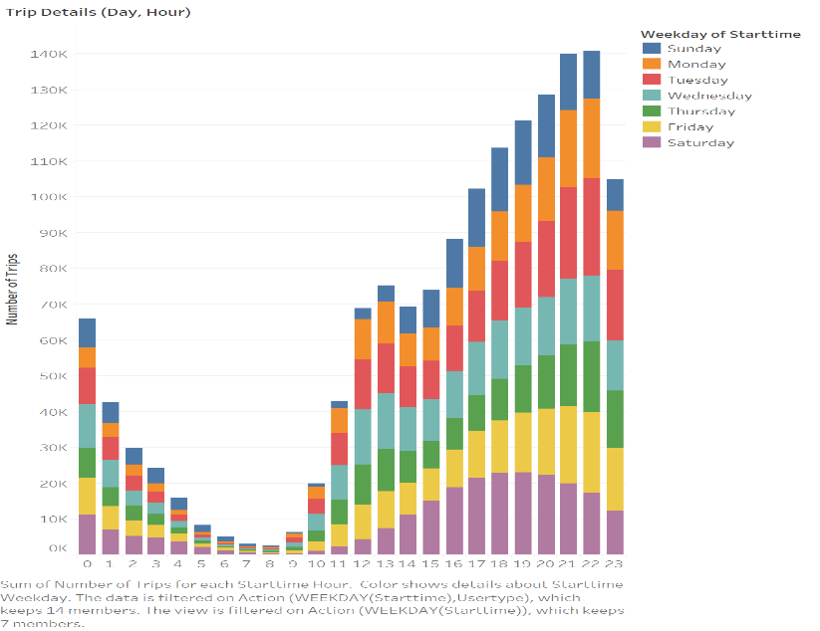The majority of city bike usage occurs towards the end of the day, as people are going to work, dinner, or back to their homes
  + The minority of usage occurs during 8 AM, which can be attributed to working hours as many NYC citizens begin their shift at this time
  + The days of week that dominate usage tend to be Friday and Saturday due to the absence of work obligations as well as potential tourism
* 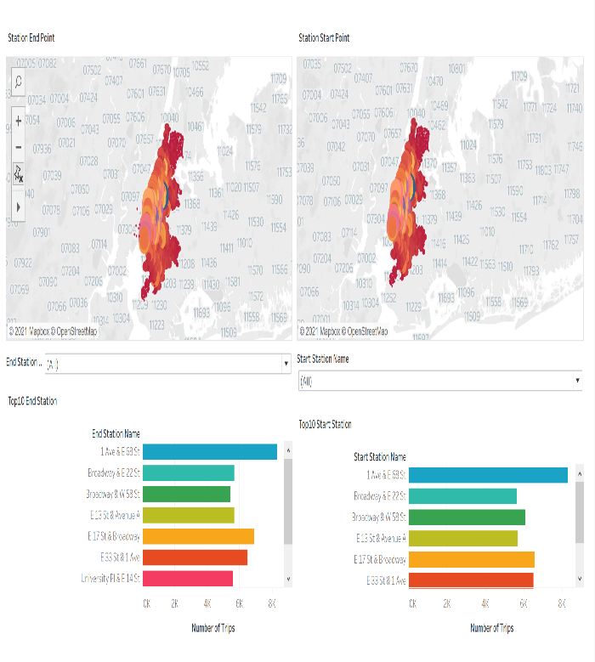**Stations by usage and start/endpoint**
  + The two stations that are used the most frequently, based on trips, are located near midtown and Manhattan which is most likely derived from the high population in these areas
  + This leads to these stations (1st Ave and E. 68th/E. 17th St and Broadway) dominating the majority of start and or/end of trips as the graphic demonstrates
* 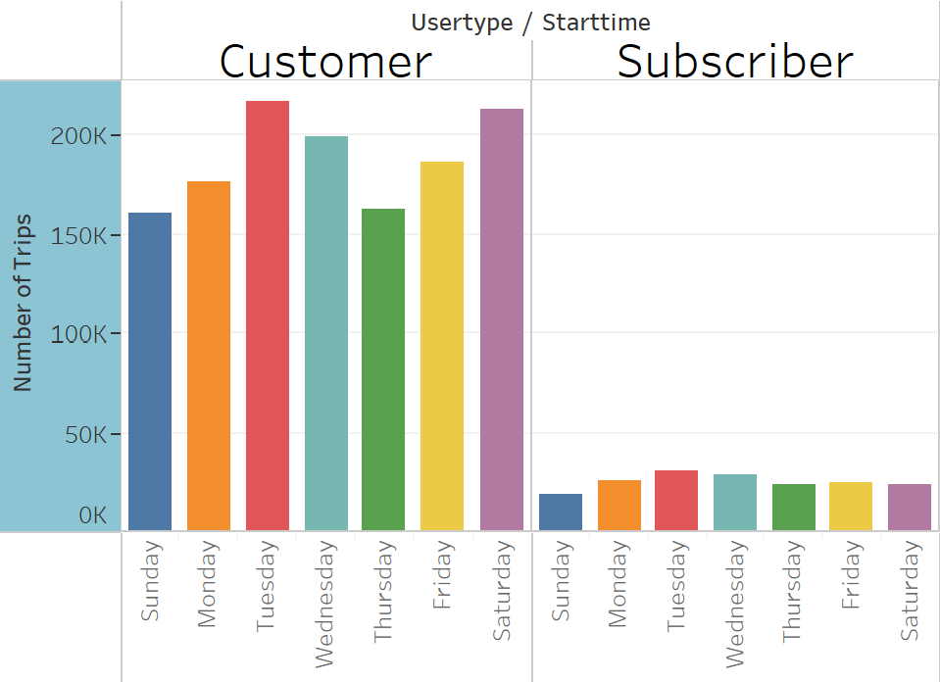**Customer Vs. Subscribers**
* As the data portrays there are far more customers than subscribers with customers having a total trip count of 217,167 during Tuesdays during march while subscribers only had 30,481
* This disparity indicates that there need to be more incentives to subscribe or an adjustment in the price of said subscription
* **Male vs. Female Users**
  + As the percentage of users graphic depicts male users were the main consumers of Citi bikes during this time period
  + The caveat of this statistic is that male subscribers more than double female subscribers for this period while they nearly identical for the count of nonsubscribers
  + Based on this information I would recommend attempting to refine the ads which target a female audience and attempt to identify the underlying cause of this desparity

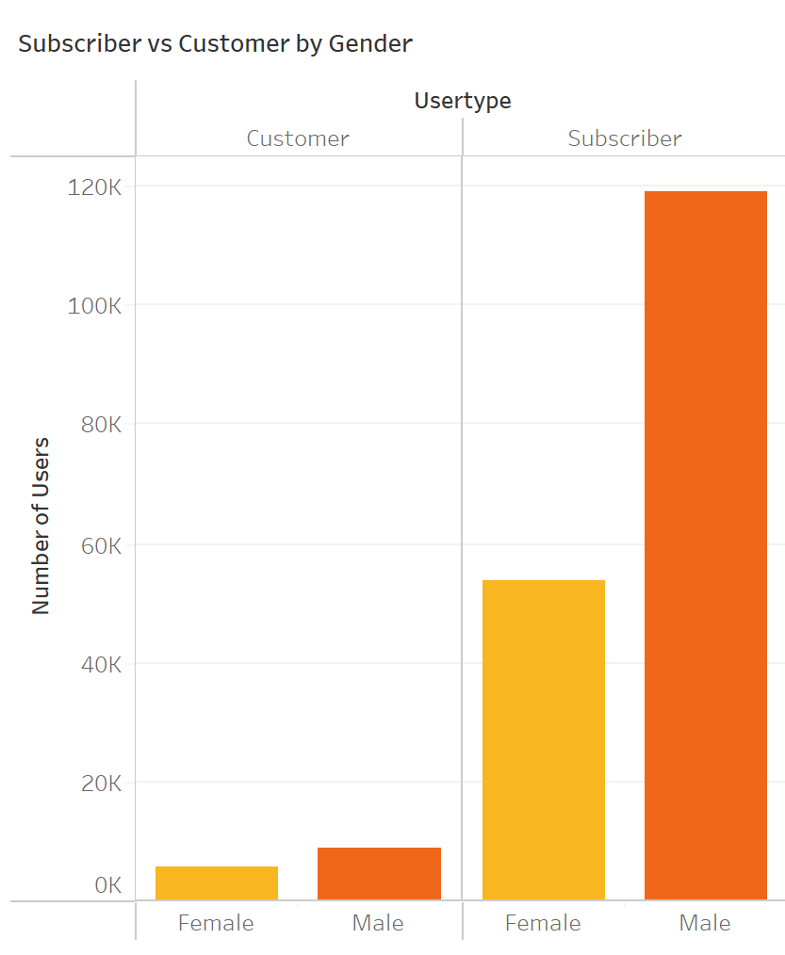

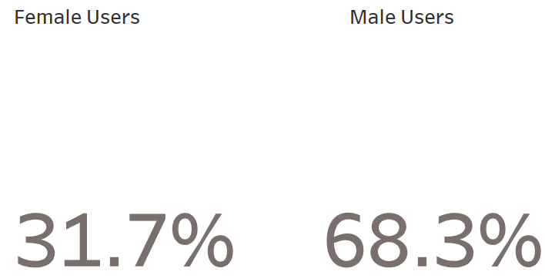

* **Age demographic of users**
  + 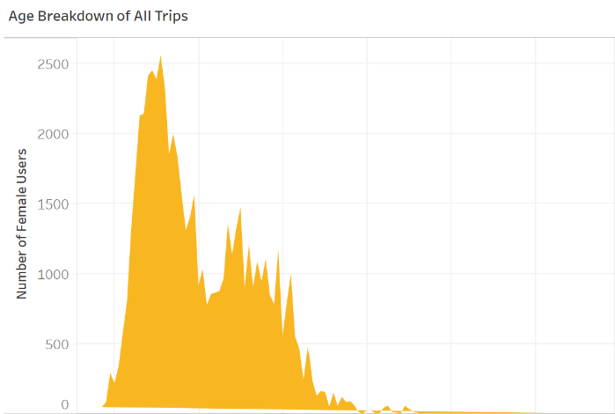The peak age of users of March 2021 both men and women is 31 years old, with the number of female users being 2,453 and the number of male users coming out to 5,869
  + 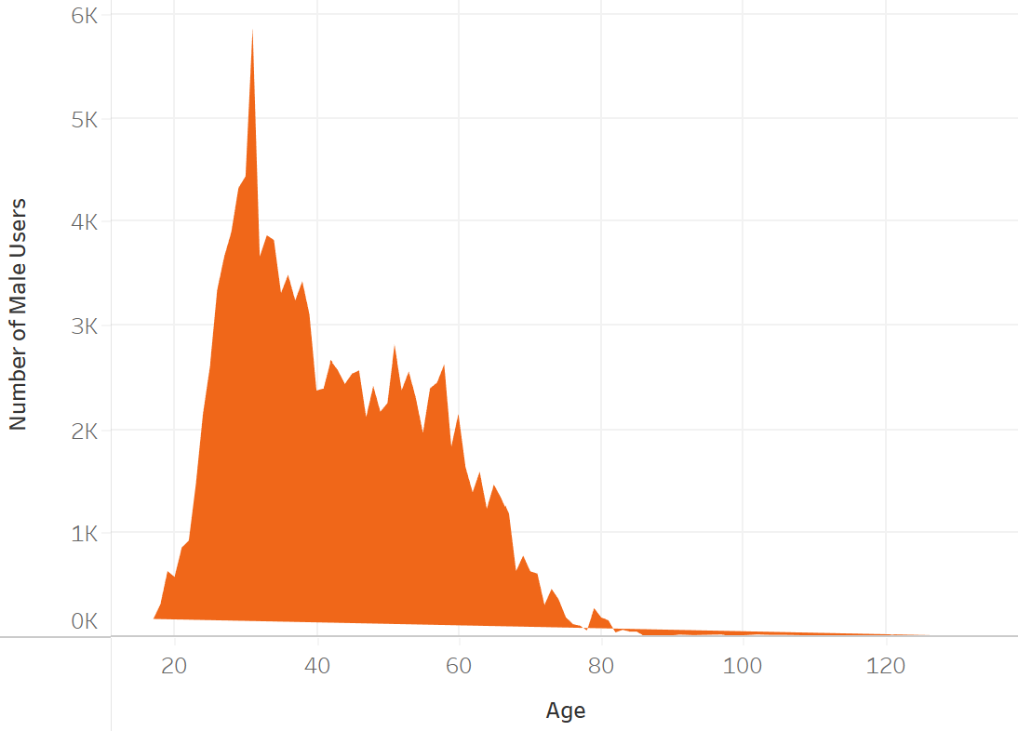This disparity furthers the need for a more well rounded marketing strategy which does more to focus on the female demographic in order to increase usage